# WhatsApp Image 2023-10-15 at 21.17.16.jpg

# 1. INTRODUCTION

## 1.1 Overview

In this Project we analysed You Tube Channels which has the highest amount of Subscribers. By doing so, we also find out the problems in You Tube. At last we suggested some solutions and enhancements that has to be done to improvise the quality of You Tube.

## 1.2 Purpose

The main Objective of the Project is to suggest You Tubers to increase their Subscribers list.

# 2. PROBLEM DEFINITION AND DESIGN THINGING

## 2.1 Empathy Map

In Empathy Map we listed common uses of You Tube. 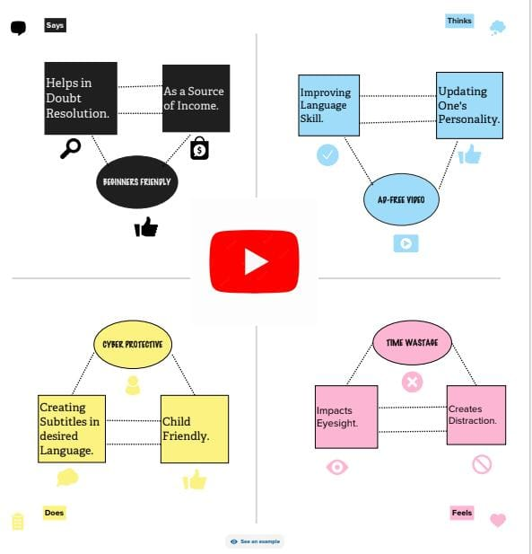

## 2.2 Ideation and Brain Storming Map

Here we have given few quality solutions and other related topics are analysed.

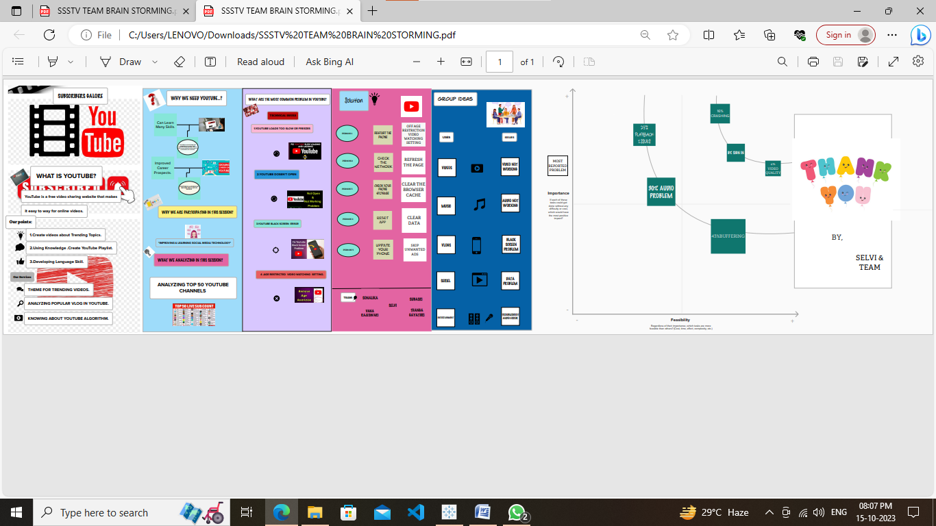

# 3. RESULT

Finally Story,Dashboard and Project report are uploaded in Github.

# 4. ADVANDAGES & DISADVANTAGES

## Advantages

*It ensures continuity watching in Videos in YouTube.

## Disadvandages

*The solutions that we have proposed is not applicate in all cases.

# 5. APPLICATIONS

* The solution can improve Consumer’s experience while using You Tube.

* It can also be used in app development.

# 6. CONCLUSION

1) First, Ideas from the team is collected and Empathy Map and Brainstorming is made.

2) Data set is downloaded from Smart Bridge.

3) Including data sets in Tableau text files.

4) 15 Sheets are created using Dashboard.

5) Then,Using Dashboard a Story is created.

6) Story and Dashboard are Published in Tableau Public.

7) Creating demonstration video.

8) Uploading the Project in Github.

# 7. FUTURE SCOPE

By Implementing the solutions an enhanced version can be created in Future.

# 8. APPENDIX

https://public.tableau.com/app/profile/selvi.m2920/viz/STORY-1_16972985885000/story1?publish=yes